

CA1

Section:

SET- A Course Code- INT253

Registration Number: |  | Max Marks:30
Name: |  | Max Time: 1 Hour

Task : CA1(Visual Implementation)

Task | Details
Objective | Create a Django application with the URL /process/<type>/<value>/. The application must accept number and text as the type and perform the required processing inside the Django view. For number, the application must determine whether the value is positive, negative, or zero and whether it is even or odd. In addition, using the tuple (1, 1, 1, 2, 2, 3, 3, 3, 4, 4, 5) and K = 2, the application must find the K most frequently occurring elements using a dictionary and loops. Built-in functions such as Counter, sort(), and sorted() must not be used. For text, the application must determine the number of characters and vowels. All results must be displayed together on the same custom HTML template/page opened through the URL. The application should handle invalid types appropriately. (30)

Expected Input :

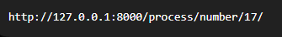

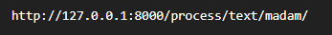

Expected Output :

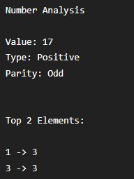

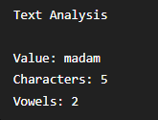



Rubrics :

Criteria | Marks | Description | Evaluation
WRITTEN | 15 | Evaluates the complete implementation of the Django application, including correct URL configuration using regular expressions and named parameters, implementation of Top-K frequency logic using a dictionary and loops, number/text processing, conditional statements, validation, and integration of the results with the custom HTML template.
PRACTICAL | 10 | Evaluates successful execution of the application, correct URL handling, accurate Top-K output, correct number/text analysis, appropriate invalid-type handling, and proper display of the required results on the URL page.
VIVA | 5 | Evaluates the student's understanding of the URL pattern, named URL parameters, Django view, dictionary-based frequency counting, Top-K logic, loops, conditional statements, request/response handling, and custom HTML template.



CA1

Section:

SET- B Course Code- INT253

Registration Number: |  | Max Marks:30
Name: |  | Max Time: 1 Hour
Task : CA1(Visual Implementation)
Task | Details
Objective | Create a Django application that accepts a customer ID and number of units through the URL in the format /bill/<customer_id>/<units>/. The application must use a regular expression URL with named URL parameters. Inside the Django view, use the tuple (1, -1, 2, -2) to find all contiguous subarrays whose sum is zero and calculate their total count. The application must also  calculate the electricity bill according to the given unit ranges and display the customer ID, units  consumed, applicable rate, bill amount, all zero-sum subarrays, and total zero-sum subarrays on the same custom HTML template/page. Invalid customer IDs and invalid or negative units must  be handled appropriately. (30)

Sample Input :

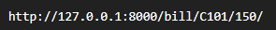

Sample Output :

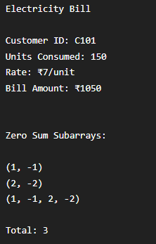

Rubrics :

Criteria | Marks | Description | Evaluation
WRITTEN | 15 | Evaluates the student's complete implementation of the Django application, including correct URL configuration using regular expressions and named parameters, zero-sum subarray logic using loops, electricity bill calculation using if-elif-else, validation of inputs, and proper integration of both results in the custom HTML template.
PRACTICAL | 10 | Evaluates the successful execution of the application, correct URL handling, accurate output for the given input, display of both zero-sum subarray results and electricity bill details on the same page, and appropriate handling of invalid inputs.
VIVA | 5 | Evaluates the student's understanding of the URL pattern, named URL parameters, Django view, zero-sum subarray logic, electricity bill calculation, conditional statements, loops, validation, and custom HTML template.



CA1

Section:

SET- C Course Code- INT253

Registration Number: |  | Max Marks:30
Name: |  | Max Time: 1 Hour
Task : CA1(Visual Implementation)
Task | Details
Objective | Create a Django application with the URL /student/<roll_no>/, where roll_no must contain exactly four digits. The application must handle GET and POST requests differently. For GET requests, display a custom HTML template containing a form to enter marks. For POST requests, read marks using request.POST and determine whether the student has passed or failed. Within the same Django view, process the given employee records using a dictionary and loops to determine the highest-paid employee in each department. The use of max() is not allowed. Both the student result and employee analysis must be displayed on the same custom HTML template/page opened through the URL. (30)

Employees Record:

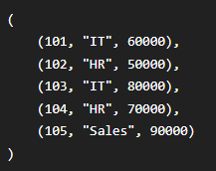

Sample Input :

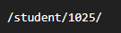

Sample Output:

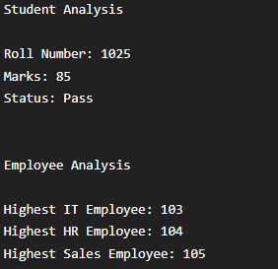

For marks below 40:

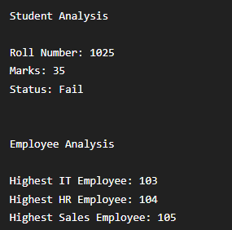

Rubrics :

Criteria | Marks | Description | Evaluation
WRITTEN | 15 | Evaluates the complete implementation of the Django application, including regular expression URL, named URL parameter, GET/POST handling, request.POST, Pass/Fail logic, dictionary-based employee grouping, loops to find the highest-paid employee, and integration of both analyses with the custom HTML template.
PRACTICAL | 10 | Evaluates successful execution of the application, correct URL handling, proper GET form display, correct POST processing, accurate Pass/Fail result, correct highest-paid employee for each department, and display of both results on the same page.
VIVA | 5 | Evaluates the student's understanding of the URL pattern, named parameters, GET and POST methods, request.POST, dictionary grouping, loops, employee comparison logic, conditional statements, Django view, and custom HTML template.



CA1

Section:

SET- D Course Code- INT253

Registration Number: |  | Max Marks:30
Name: |  | Max Time: 1 Hour
Task : CA1(Visual Implementation)
Task | Details
Objective | Create a Django application with the URL /date/<day>/<month>/<year>/. The URL should use a regular expression to enforce the required format and named URL parameters. The Django view must perform both of the following tasks and display their results on the same custom HTML template/page. (1) Using the given tuple of words ("eat", "tea", "tan", "ate", "nat", "bat"), group words that are anagrams of each other. The student must use a dictionary and loops to create a character-frequency-based signature for grouping anagrams. Built-in sorted() and external libraries must not be used. (2) Validate the date received through the URL and determine whether it is Valid or Invalid. For a valid date, display the day, month, year, and valid-date status. (30)

Anagram Input:
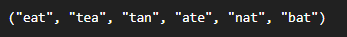

Sample Input (a):

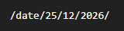

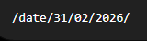

Sample Output (a):

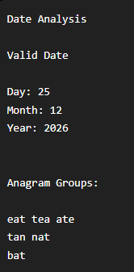

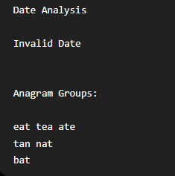

Rubrics :

Criteria | Marks | Description | Evaluation
WRITTEN | 15 | Evaluates the complete implementation of the Django application, including regular expression URL, named URL parameters, date validation, dictionary-based anagram grouping, character-frequency signature, loops, conditional statements, and integration of both tasks with the custom HTML template. sorted() and external libraries must not be used.
PRACTICAL | 10 | Evaluates successful execution of the application, correct URL handling, accurate valid/invalid date identification, correct grouping of anagrams, and proper display of both date analysis and anagram groups on the same URL page.
VIVA | 5 | Evaluates the student's understanding of the URL pattern, named parameters, Django view, date validation, dictionary grouping, character-frequency signature, loops, conditional statements, and custom HTML template.



CA1

Section:

SET- E Course Code- INT253

Registration Number: |  | Max Marks:30
Name: |  | Max Time: 1 Hour
Task : CA1(Visual Implementation)
Task | Details
Objective | Create a Django application with the URL /employee/<emp_id>/<salary>/. The URL should accept the employee ID and salary and display the results of both the Employee Salary Calculator and Transaction Fraud Detector on the same custom HTML template/page. The employee ID  must contain exactly 5 digits, and the salary must contain only digits. Use if-elif-else to classify the employee and calculate the bonus. Inside the same Django view, process the given tuple of transactions, group transactions by account using a dictionary, calculate the total transaction amount and transaction count for each account, and identify suspicious accounts where the total transaction amount exceeds the given limit AND the account has more than the minimum number of transactions. The application should handle the case where no suspicious account exists.

Sample Input :
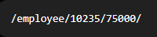

Sample Output :

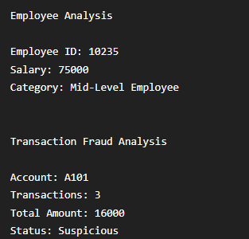

Rubrics :

Criteria | Marks | Description | Evaluation
WRITTEN | 15 | Evaluates the complete implementation of the Django application, including named URL parameters, Django view, employee salary classification using if-elif-else, dictionary-based transaction grouping, transaction counting, total transaction calculation, application of both fraud conditions, and integration of both analyses with the custom HTML template.
PRACTICAL | 10 | Evaluates successful execution of the application, correct URL handling, accurate employee category, correct identification of suspicious accounts, correct transaction count and total amount, and proper display of both outputs on the same URL page.
VIVA | 5 | Evaluates the student's understanding of named URL parameters, Django view, salary classification, dictionary grouping, loops, transaction counting, total calculation, fraud conditions, and custom HTML template.



CA1

Section:

SET- F Course Code- INT253

Registration Number: |  | Max Marks:30
Name: |  | Max Time: 1 Hour
Task : CA1(Visual Implementation)
Task | Details
Objective | Create a Django application with the URL /operation/<operation>/<number>/. The URL should accept an alphabetic operation name and an integer number. The Django view must perform both the Smart Operation Router and Longest Consecutive Sequence tasks, and their results must be displayed on the same custom HTML template/page opened through the URL. For the operation analysis, use if-elif-else to perform the requested operation: square, cube, even, odd, prime, or factorial. For the longest consecutive sequence analysis, use the given unsorted tuple  (100, 4, 200, 1, 3, 2) and find the length and sequence of the longest consecutive integers. A dictionary must be used for existence checking, and sort() and sorted() must not be used. (30)

Sample Input :
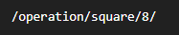

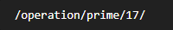

Sample Output :

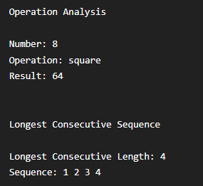

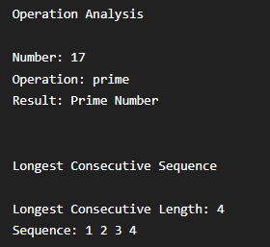

Rubrics :

Criteria | Marks | Description | Evaluation
WRITTEN | 15 | Evaluates the complete implementation of the Django application, including regular expression URL, named URL parameters, Django view, if-elif-else operation handling, implementation of all supported operations, dictionary-based longest consecutive sequence logic, loops, and integration of both results with the custom HTML template. sort() and sorted() must not be used.
PRACTICAL | 10 | Evaluates successful execution of the application, correct URL handling, accurate results for the selected operation, correct longest consecutive sequence and length, proper handling of invalid operations, and display of both results on the same URL page.
VIVA | 5 | Evaluates the student's understanding of the URL pattern, named URL parameters, Django view, if-elif-else, operation logic, dictionary-based existence checking, loops, longest consecutive sequence logic, and custom HTML template.



CA1

Section:

SET- G Course Code- INT253

Registration Number: |  | Max Marks:30
Name: |  | Max Time: 1 Hour
Task : CA1(Visual Implementation)
Task | Details
Objective | Create a Django application with the URL /student/<roll_no>/<marks>/. The URL must accept a roll number containing exactly 4 digits and marks containing 1–3 digits. The Django view must perform both the Smart Student Result Analysis and First Missing Positive Integer Analysis, and display their results on the same custom HTML template/page opened through the URL. For the student result, validate the marks using if-elif-else and assign the appropriate grade and status. For the missing positive analysis, use the given unsorted tuple (3, 4, -1, 1) to find the smallest positive integer that does not occur in the tuple. sort() and set() must not be used; loops/dictionary must  be used. (30)

Sample Input :
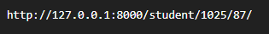

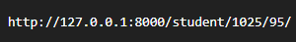

Sample Output :

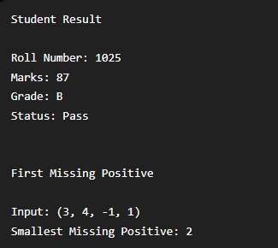

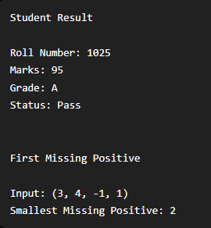

Rubrics :

Criteria | Marks | Description | Evaluation
WRITTEN | 15 | Evaluates the complete implementation of the Django application, including regular expression URL, named URL parameters, Django view, student marks validation using if-elif-else, grade classification, dictionary/loop-based First Missing Positive logic, and integration of both results with the custom HTML template. sort() and set() must not be used.
PRACTICAL | 10 | Evaluates successful execution of the application, correct URL handling, accurate student grade and status, correct identification of the smallest missing positive integer, appropriate handling of invalid marks, and display of both results on the same URL page.
VIVA | 5 | Evaluates the student's understanding of the URL pattern, named URL parameters, Django view, marks validation, if-elif-else, dictionary/loop logic, First Missing Positive algorithm, and custom HTML template.



CA1

Section:

SET- H Course Code- INT253

Registration Number: |  | Max Marks:30
Name: |  | Max Time: 1 Hour
Task : CA1(Visual Implementation)
Task | Details
Objective | Create a Django application with the URL /date/<day>/<month>/<year>/. The URL should use a regular expression to enforce the required format and named URL parameters. The Django view must perform both the Date-Based Day Classifier and Longest Subarray With Equal 0s and 1s tasks, and display their results on the same custom HTML template/page opened through the URL. For the date analysis, determine whether the given date is Valid or Invalid. For a valid date, classify the month as Winter, Spring, Summer, or Autumn. For the longest subarray analysis, use the given tuple (0, 0, 1, 0, 0, 0, 1, 1) to find the length of the longest contiguous subarray containing an equal number of 0s and 1s. The coding logic must use a dictionary and loops. Counter, max(), sort(), and sorted() must not be used. (30)

Sample Input :


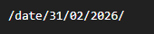

Sample Output :

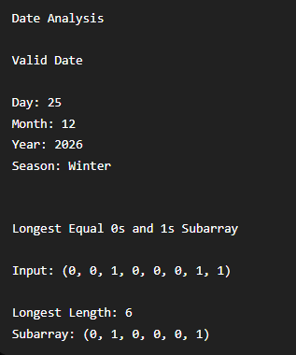

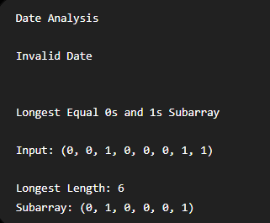

Rubrics :

Criteria | Marks | Description | Evaluation
WRITTEN | 15 | Evaluates the complete implementation of the Django application, including regular expression URL, named URL parameters, Django view, date validation, month/season classification, dictionary-based prefix-sum logic for finding the longest subarray with equal 0s and 1s, loops, and integration of both results with the custom HTML template. Counter, max(), sort(), and sorted() must not be used.
PRACTICAL | 10 | Evaluates successful execution of the application, correct URL handling, accurate valid/invalid date identification, correct season classification, correct longest subarray length and subarray, and proper display of both results on the same URL page.
VIVA | 5 | Evaluates the student's understanding of the URL pattern, named URL parameters, Django view, date validation, season classification, prefix-sum logic, dictionary indexing, loops, and custom HTML template.



CA1

Section:

SET- I Course Code- INT253

Registration Number: |  | Max Marks:30
Name: |  | Max Time: 1 Hour
Task : CA1(Visual Implementation)
Task | Details
Objective | Create a Django application with the URL /student/<student_name>/. The Django view must perform both the Student Login Using HTTP Method and Majority Element With Verification tasks, and display their results on the same custom HTML template/page opened through the URL. For the student login, the view should behave differently based on the HTTP method. For GET requests, display the student name and a message requesting credentials. For POST requests, accept username and password and display either a successful login message or invalid credentials message. For the majority element analysis, use the given tuple (2, 2, 1, 1, 1, 2, 2). The student must first determine a possible majority candidate and then verify its frequency. If no element appears more than n/2 times, display No Majority Element. (30)

Sample Input :
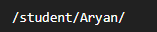

Sample Output :

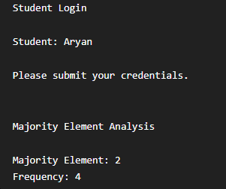

Rubrics :

Criteria | Marks | Description | Evaluation
WRITTEN | 15 | Evaluates the complete implementation of the Django application, including regular expression URL, named URL parameters, Django view, date validation, month/season classification, dictionary-based prefix-sum logic for finding the longest subarray with equal 0s and 1s, loops, and integration of both results with the custom HTML template. Counter, max(), sort(), and sorted() must not be used.
PRACTICAL | 10 | Evaluates successful execution of the application, correct URL handling, accurate valid/invalid date identification, correct season classification, correct longest subarray length and subarray, and proper display of both results on the same URL page.
VIVA | 5 | Evaluates the student's understanding of the URL pattern, named URL parameters, Django view, date validation, season classification, prefix-sum logic, dictionary indexing, loops, and custom HTML template.

